IT340 Mid-Term

Matthew Young

1. An insert anomaly would be a new appointment being logged without a surgeryNo. A duplication anomaly would be if the information was modified in all but one or more of the data duplicates. A delete anomaly would occur when an attribute was deleted and caused another attribute to also be altered or deleted.
3. I’m not sure what you mean by rationale, so I’ll just tell you that I followed all the rules of 1NF, 2NF, and 3NF. My assumptions about the business rules are as follows:
   1. A Staff member can have zero or many Appointments
   2. An Appointment must have a Staff member
   3. An Appointment cannot have more than one Staff member
   4. A Patient can have zero or many Appointments
   5. An Appointment must have a Patient
   6. 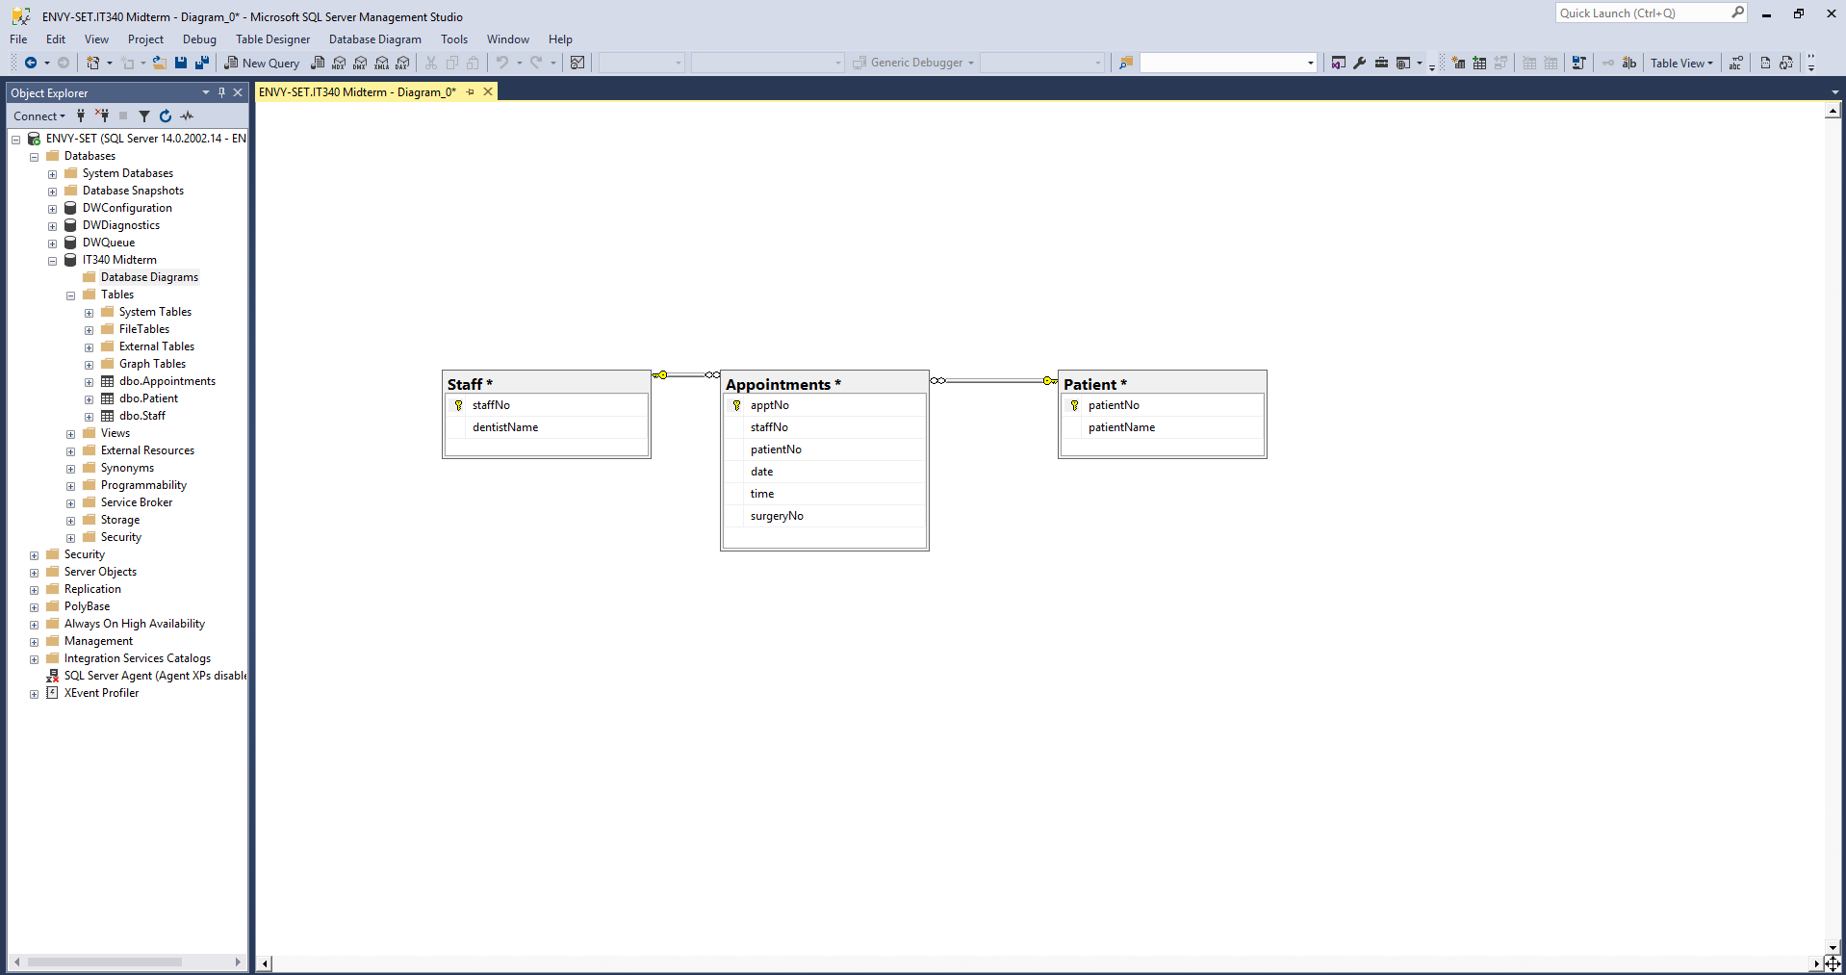An Appointment cannot have more than one Patient
4. Yes my 3NF tables did accurately reflect my initial ERD.